Impact of Black & Hispanic/Latinx ethnicities on the Technology Field in 2020

Edras H & Fatoumata B.

CUNY New York City College Of Technology

Author Note

[Include any grant/funding information and a complete correspondence address.]

Abstract

Data Warehouse can be defined to understand data better to analyze a business performance. Data miming on the other hand, focuses on discovering data, extracting data, and finding patterns. Moreover, business intelligence is the data analysis to address a problem or solution in a company. Nowadays, many companies are using these three concepts to improve their products, services and meets their goals. Many companies are interested in having a diverse culture in their work environment. Some companies might hire people from different ethnicities while others may not. It’s no wonder that some races succeed in some fields than other races, but this problem has been carrying on throughout the years. The technology is a very broad field that can offer many career opportunities and it’s believed that more positions will be available in the next few years. However, the Black and Hispanic community are being left behind in the technology field. Therefore, Data Warehouse, Data Mining and business will be used to interpret and conclude if there the Black and Hispanic community are interested in the technology field.

Keywords: Hispanic, Technology

Impact of Black & Hispanic/Latinx ethnicities on the Technology Field in 2020

# Introduction

To find out the impact of Black and Hispanic in technology field, a data warehouse with stage area and data marts was decided for analyzing of the data.

## Data Warehouse Architecture and Design1

### SSIS Design.

1. **Creating the database in MS SQL Server 2019: The name of the Database is named** Men&WomanTechDW

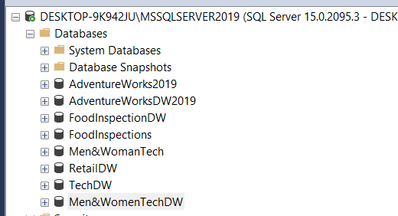

1. **Importing the raw data to the Stage Tables created**

First table loaded is Stage_Dept_GenderRace

Second table where RawData is imported is Stage_Dept_Gender

Third table is Stage_YearGender

1. **Creating Dimensional Tables**

Once Stage tables have been created and load it, we can proceed to identify what dimension and fact tables will be created. For this Database, three dimensional tables have been identified. DimEthnicity, DimDept, and Dim_Gender

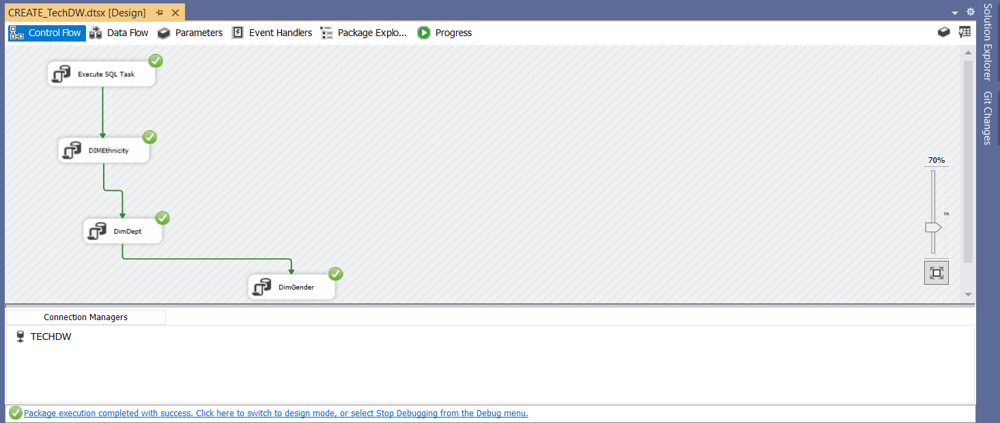

1. **Importing Data from Stage Table to Dimensional Tables**

Data from StageDept_GenderRace was used to transfer to the three-dimensional tables because it has the necessary information to later create the Fact table.

**Image 1(DimDeptTABLE)**

Image 2 (DimEthnicity table)

Image 3 (DimGender table)

1. **Confirm Dimensional tables have been populated**

It is important to check if the dimensional tables were populated to see if something is missing. We can check this by opening our database in MS SQL server.

**Image1 (DimDept table)**

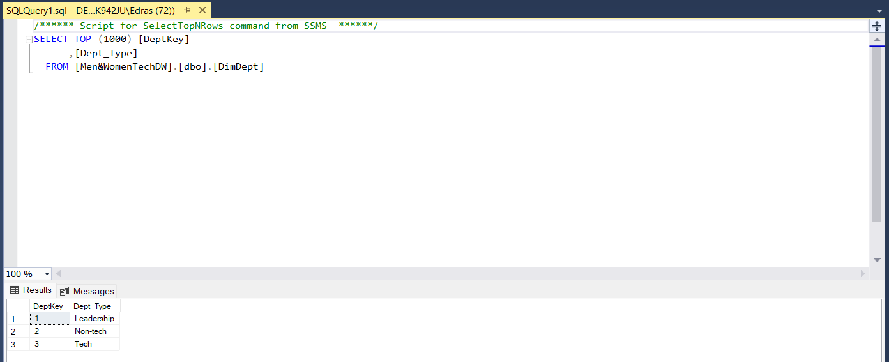

On the image above, the table DimDept has been populated with its DeptKey, and corresponding department.

**Image 2 (DimEthnicity)**

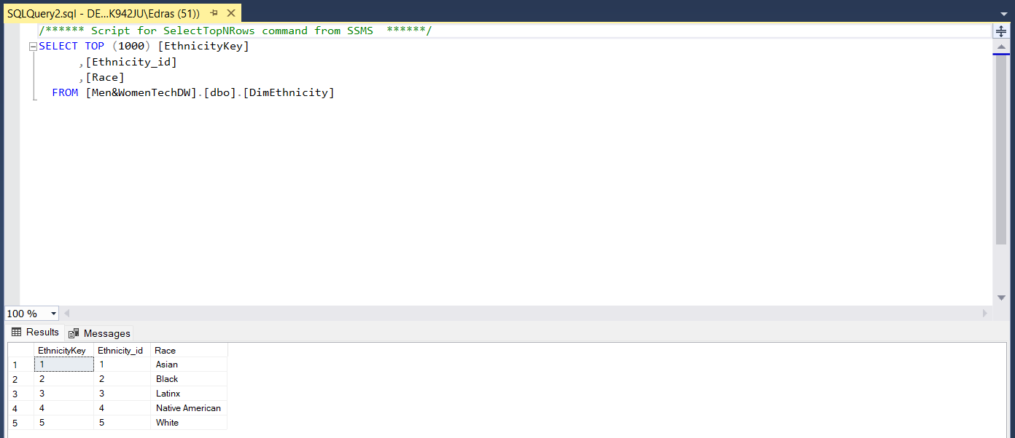

On the image above, table DimEthnicity has also been populated and has unique values.

Image 3 (DimGender)

1. **Creating the Fact table**

Once all Dimensional tables have been created and populated, the last step is to create a Fact table that will hold all measurements to do the report on Hispanic and Black ethnicity in Technology field.

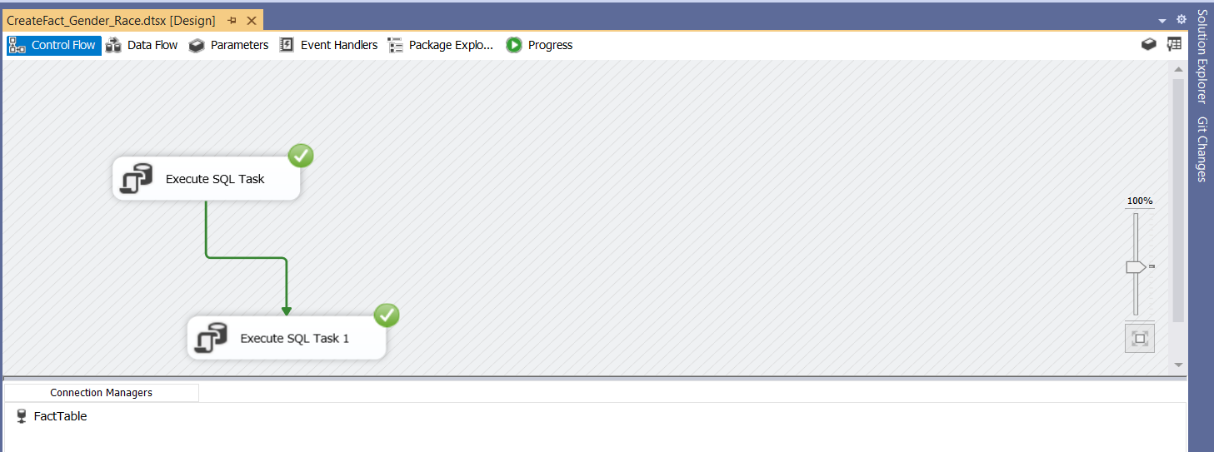

On the image above, a SQL task was performed to create the Fact table called Fact_Gender_Race

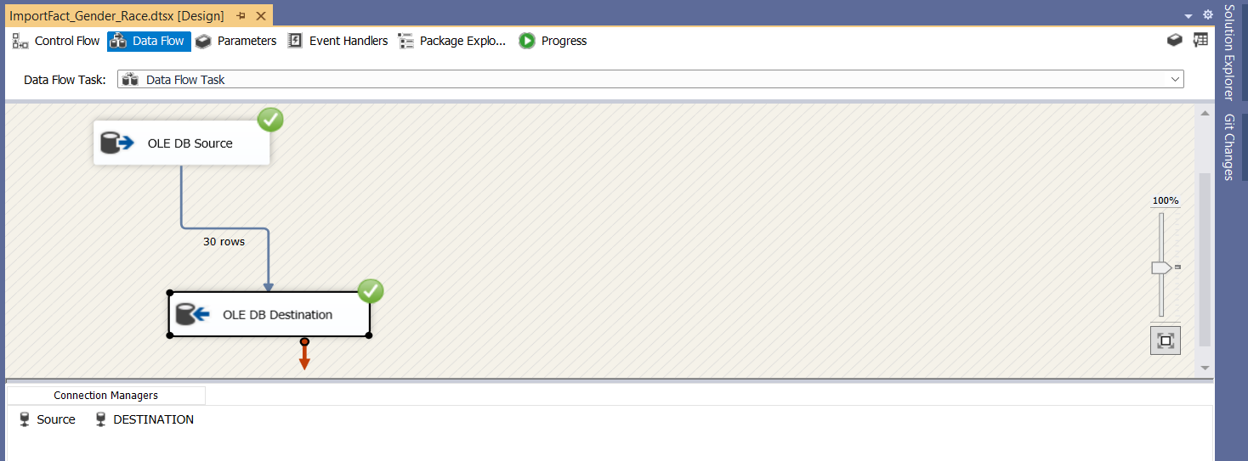

Image above, a data flow task was used to transfer all data from Stage_Dept_GenderRcae to Fact_Gender_Race.

1. **Creating a Star Schema**

This schema will be used later to analyze and perform the report about the gap between Black/Hispanic and other races in the technology field.

#### SSAS Design.

[When using headings, don’t skip levels. If you need a heading 3, 4, or 5 with no text following it before the next heading, just add a period at the end of the heading and then start a new paragraph for the subheading and its text.] (Last Name, Year)

##### Analysis

Reports

[Like all sections of your paper, references start on their own page. The references page that follows is created using the Citations & Bibliography feature, available on the References tab. This feature includes a style option that formats your references for APA 6th Edition. You can also use this feature to add in-text citations that are linked to your source, such as those shown at the end of this paragraph and the preceding paragraph. To customize a citation, right-click it and then click Edit Citation.] (Last Name, Year)

#### SSRS.

[When using headings, don’t skip levels. If you need a heading 3, 4, or 5 with no text following it before the next heading, just add a period at the end of the heading and then start a new paragraph for the subheading and its text.] (Last Name, Year)

##### Analysis

Reports

[Like all sections of your paper, references start on their own page. The references page that follows is created using the Citations & Bibliography feature, available on the References tab. This feature includes a style option that formats your references for APA 6th Edition. You can also use this feature to add in-text citations that are linked to your source, such as those shown at the end of this paragraph and the preceding paragraph. To customize a citation, right-click it and then click Edit Citation.] (Last Name, Year)

Conclusion

What did you find

Suggestions for future project

What is the you did not have time to analyze and suggest others for future research.

References

Last Name, F. M. (Year). Article Title. *Journal Title*, Pages From - To.

Last Name, F. M. (Year). *Book Title.* City Name: Publisher Name.

Footnotes

1[Add footnotes, if any, on their own page following references. For APA formatting requirements, it’s easy to just type your own footnote references and notes. To format a footnote reference, select the number and then, on the Home tab, in the Styles gallery, click Footnote Reference. The body of a footnote, such as this example, uses the Normal text style. (Note: If you delete this sample footnote, don’t forget to delete its in-text reference as well. That’s at the end of the sample Heading 2 paragraph on the first page of body content in this template.)]

Tables

Table 1

[Table Title]

|  |  |  |  |  |
| --- | --- | --- | --- | --- |
| Column Head | Column Head | Column Head | Column Head | Column Head |
| Row Head | 123 | 123 | 123 | 123 |
| Row Head | 456 | 456 | 456 | 456 |
| Row Head | 789 | 789 | 789 | 789 |
| Row Head | 123 | 123 | 123 | 123 |
| Row Head | 456 | 456 | 456 | 456 |
| Row Head | 789 | 789 | 789 | 789 |

Note: [Place all tables for your paper in a tables section, following references (and, if applicable, footnotes). Start a new page for each table, include a table number and table title for each, as shown on this page. All explanatory text appears in a table note that follows the table, such as this one. Use the Table/Figure style, available on the Home tab, in the Styles gallery, to get the spacing between table and note. Tables in APA format can use single or 1.5 line spacing. Include a heading for every row and column, even if the content seems obvious. A default table style has been setup for this template that fits APA guidelines. To insert a table, on the Insert tab, click Table.]

Figures title:

Figure 1. [Include all figures in their own section, following references (and footnotes and tables, if applicable). Include a numbered caption for each figure. Use the Table/Figure style for easy spacing between figure and caption.]

For more information about all elements of APA formatting, please consult the APA Style Manual, 6th Edition.